**Replacement Reserve**

**Automation**

**Download from Yardi**

1. Copy and Paste Download (from Yardi) into an Excel worksheet and label worksheet “Download from Yardi.” There might be a different name other than “Yardi.” Yardi is the name of an accounting package.

**Eliminate Column A to D and Sort by Check Number**

1. Make a copy of the “Download from Yardi” worksheet and rename it “Elim Col A to D & Sort by Chk #.” The name of this worksheet might change later.
2. Delete columns “A” through “D”
3. Eliminate lines without spaces or without data
4. Highlight cells A6 to O166
5. Select keys “FN” + “F5”
6. Select “Special” from the dialog box “Go To…”
7. From the “Special” select “Blanks”
8. Go to the Ribbon and select “Delete” from the Cell section
9. Select “Delete Sheet Rows”

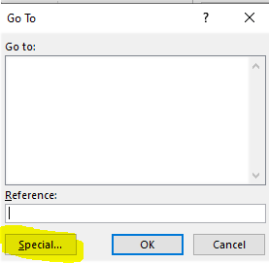

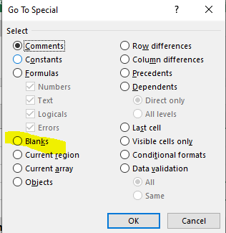

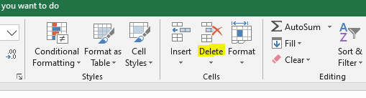

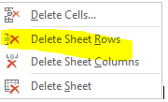

1. Sum Column “I” or “Amount” for a Grand Total
2. Reference cell “M138” from cell “M168” from worksheet “Download from Yardi.”
3. Ensure no data was lost. The difference between cell M138 and M140 should equal Zero. See Cell I140.
4. In cell “F138” or two lines down from the Grand Total amount, place a title “Download from Yardi Total”
5. In cell “F140” “place a title “Difference (Must Be Zero) with a double underscore and single over-score.

**Identify Replacements**

1. Make a copy of the worksheet label “**Elim Col A to D & Sort by Chk** #” and relabel it “**Identify Replacements**.”
2. Sort by “Check Number” or “Column L”
3. Find last check submitted to the lender for reimbursement (The last check number is found from the previous quarters report” There should be a “Input Box or field” in the programming to flag the request or reference cell “C4” from the “Input Information worksheet.”
4. Assume the last check was #4346 or Line 26
5. Place a line under Line 26
6. Add a new column to the right of column “I” or “Amount” and label its “Replacements.” The column should be “J.”
7. In column “N” find and highlight in green items compared to list from the worksheet labeled “Acceptable Replacements”
8. A dialog box should appear asking for the “Reserve Balance.” The “Reserve Balance” is obtained from the Lender’s website.
9. Let’s assume the Reserve Balance” is $9,978. Reference the amount from the “Input Information” worksheet, into cell “J142.”
10. Of those lines highlighted in step 6 above, add the amounts from column “I” or “Amount” to column “J” or “Replacements” while adding the amounts that is equal to or closes to the “Reserve Balance” of $9,978.
11. Sum the amounts in column “J” or “Replacements” on the same line as the “Grand Total” of Column “I”
12. In cell J144, subtract the total from cell J136 from the amount in cell J142 or “Replacement Reserve”. The goal is to reach $9,978 without going over. At this moment, the last check is #4470 and the sum total is $9,105.40.
13. Now, I stopped at check #4470 because if I had added line 80 for $504.65, I would have derived $9,610.05 with check number 4502. However, I would not be able to submit this check next quarter. Consequently, reimbursable items from line 83 to 87 would not be reportable. I would lose the right to submit the 5 items. The rule is a check can only be submitted once. So, check number 4502 will be the first check submitted next quarter.
14. For those lines that were highlighted in green but were not considered this period will carry over into the next quarter.

**Formatting-Prelim**

1. Make a copy of the “Identify Replacement” worksheet and label it “Formatting-Prelim”
2. Sort on column “J” or “Replacements” to which the Non-Acceptable Replacements will be segregated.
3. Delete the lines with the “Non-Acceptable Replacements” or lines that had not been highlighted in green.
4. Delete the following Columns:
5. “B” or “Payable Control”
6. “K” or “Unpaid Amount”
7. “C” or “Batch”
8. “J” or “Replacements
9. Ensure that the “Amount” column equals the same as the “Replacement” or column “J” from the “Identify Replacements” worksheet. In this case the amount should equal $9,105.40.

**Sort By & Total by Check #**

1. Make a copy of “Formating-Prelimin” and label the new worksheet “Sort By & Total by Check #”
2. Sort the report by column “I” or “Check #”
3. Add a new column after column “I” or “Check #” and label it “Check Amt”
4. Sum column “G” or “Amount” in column “J” or “Check Amt”
5. Place a line under each unique check number
6. Sum total the individual amounts in column “G” or “Amount” for each unique check and place the total on the last line of the unique check in column “J” or “Check Amt.” Do not reference cells from column “G” or “Amount” for the totals for each unique check in column “J” or “Check Amt” because column “G” or “Amount” is deleted in an upcoming step and if they totals are linked to the column “G” or “Amount” then the summations will fail.

**Report-Prelim**

1. Make a copy of “Sort by and Total Check Number” and label the new worksheet “Report-Prelim”
2. Move the column “L” or “Notes” to column “A”
3. In column “A” or “Notes” if there are more than one line with the same type of replacements (i.e. water heater), by check, then place all the same replacements items on one line and add the individual apartment numbers to the description (yet the replaced items should be mentioned only once. Please see cell A12.) In cell A12, there are the 3 apartment numbers listed with only one description of the “Water heater replace)

Please see lines 15 through 19 on the “Sort By & Total by Check” worksheet. There are three lines with water heaters replace with three different amounts and two lines with AC replace with two different amounts for check number 3243.

Now, on the “Report-Prelim” worksheet these 5 lines have been reduced to two lines: one line for water heaters for a total of $1,416.69 and one line for AC for a total of $1,826.

**Report-Final**

1. Make a copy of “Report-Final” and label the new worksheet “Report-Final”
2. Delete the following columns:
3. Column “G” or “System Method”
4. Column “H” or “Amount”
5. Column “I” or “Check Control”

**Form Letter with Replacements**

1. Copy and paste the completed report data into the form letter.